AUTH-006
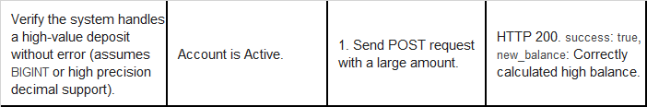
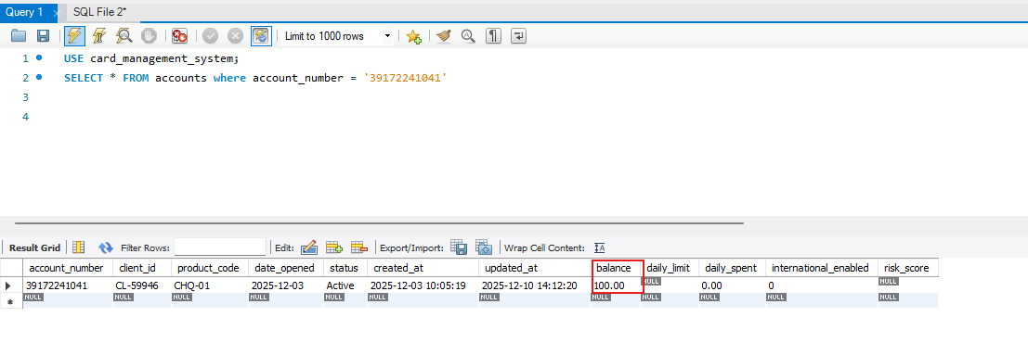
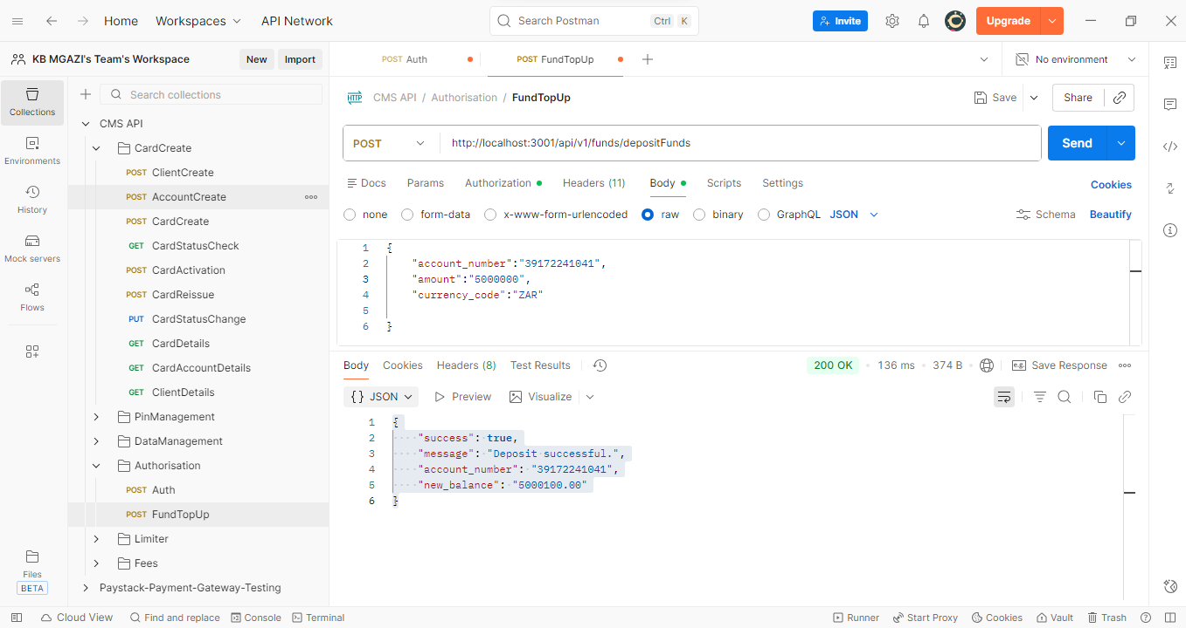
Request:
{
"account_number":"39172241041",
"amount":"5000000",
"currency_code":"ZAR"

}
Response:
{
"success": true,
"message": "Deposit successful.",
"account_number": "39172241041",
"new_balance": "5000100.00"
}

